The Dead Sea Scrolls and
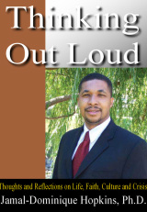
The Untold Story of Africans in the Bible:
Towards Honoring and Healing Our Community

Rev. Dr. Jamal-Dominique Hopkins
Where: Greater New Guide Baptist Church
Pastor Sterling Brown
2162 Summit Ave
Altadena, CA 91001-5722
When: Friday, July 24, 2015. 7:00-9:00 pm.
Suggested donation: $10.
Jamal-Dominique Hopkins (Ph.D., University of Manchester) is President/C.E.O. of the non-profit Christian think-tank, the Institute for Advanced African American Christian Thought Inc., and Founder and Director of J.D. Institute, a public intellectual institute engaged in social and cultural thought from a biblical perspective. He currently resides in Altadena with his family.
Rev. Sterling Brown is founder and pastor of the Greater New Guide Baptist Church and a member of the Interdenominational Ministerial Alliance (IMA)

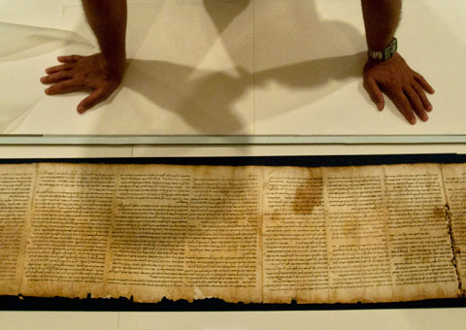
Donations will be matched and go to the North Fair Oaks Empowerment Project, an initiative of churches, businesses and individuals committed to improving this neglected section of Pasadena.

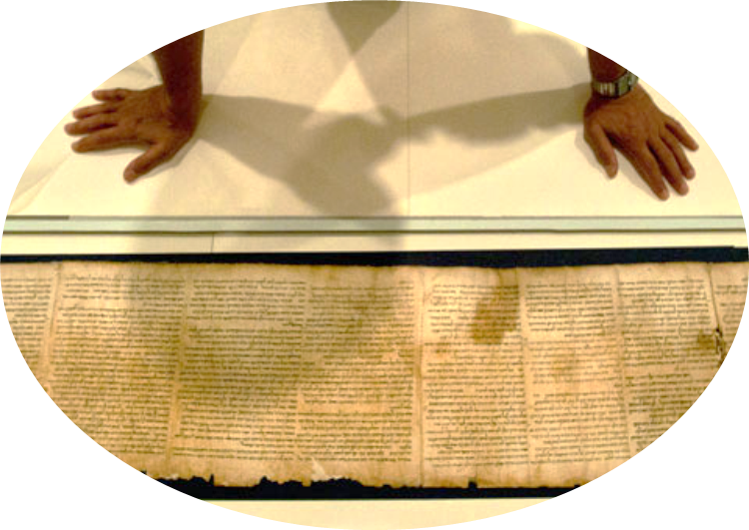
“Rev. Dr. Jamal-Dominique Hopkins is an important voice in the 21st-century Black Evangelical ‘school of the prophets.’ He speaks uniquely if not singularly to the Black academic excellence of scholarship in the Dead Sea Scrolls.”—National Black Evangelical Association, Chicago, IL

