
Are you a friend of Granny?
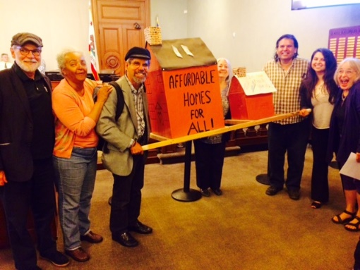
and Granny Flats?
(Those cute back houses are now called ADUs— Accessary Dwelling Units—or sometimes: “A mini home for living large in a small footprint within a finite spaceship called planet Earth….”)
If you support having more ADUs in Pasadena, then please join us. Our goal is to fill the Council Chambers with 100 people!
Where: The Pasadena City Council Chambers.
100 North Garfield Avenue, Room S249 (the SE corner of the Second Floor of City Hall)
Monday, Dec. 11th at 7pm.
We can make a huge difference to help retain a healthy mix of opportunities to adequately house our city and help prevent displacement.
See the back of his flyer for the Greater Pasadena Affordable Housing Group is proposing.
Any Questions, of if you wish to speak during the council meeting, contact,
Jill Shook 626) 675-1316
Jill@makinghousinghappen.com
Greater Pasadena Affordable Housing Group’s recommendations

- We recommend no Minimum lot size requirement to build a detached ADU. While we are thankful that the Planning Commission voted to adjust their recommendation to the City Council from 15,000 to 5,000 square feet property size in their last proposal to the City Council, we are recommending that Pasadena follow the lead of Arcadia, Burbank, Glendale, Monrovia, and LA County (Altadena), all which have no minimum lot size for detached ADUs. No more than 35% of single family home properties in Pasadena can be covered with structure. This alone is a significant deterrent to ADUs. Santa Cruz allows ADUs on properties of 4,500 square feet, Long Beach 4,800, Santa Monica 4,000 and some cities, Beverly Hills 6,000 and San Jose at 5,445.

- ADUs should be allowed in all Landmark Districts, with or without the units being visible from the street.

- Increase the present 800 square feet limit on the unit size of the ADU to 1,200 square feet or 50% of the primary home, which is congruent with what the state law allows. This small 800 s.f. size is arbitrarily low, and does not accommodate the spatial needs of families residing in accessory residences. To have a healthy community and thriving school district we need children. 1,200 s. f. or 50% of the total living area of the primary dwelling is what South Pasadena, LA County, Santa Cruz and most cities allow.

- We are recommending that ADUs be allowed above garages by increasing the height to 25 feet. Pasadena allows homeowners to have a second floor in their homes and an ADU over an attached garage. Our recommendation is consistent with this. We are concerned about privacy issues and believe this can be mitigated by having no windows or entrances facing neighbors. Having the option to build an ADU above the garage will preserve off street covered parking and open space on a property. Instead of creating a new impervious surface, building above the garage is often more sensible to the environment.

- The fees for ADUs in Pasadena for a 900 s.f. property are about $50,000, this is excessive and needs to be greatly decreased. (Temple City fees are $3,000). This is a deterrent from incentivizing homeowners to help contribute to California’s shortfall of 1.3 million housing units which is pushing up the cost. Santa Cruz, CA does all they can to incentivize ADUs, including building over garages, free architectural plans, low cost loans and more, but even with all these incentives, typically only 10-12 are built in a year. This low number of added units to Pasadena’s housing stock does not affect traffic or unfounded fears of higher density. These fees should be cut in half if not more.

In addition to attending the City Council on Dec. 11th, we urge you to also send your comments to the City Council. Our goal is 100 comments. Include just one or as many of the above points you feel you can support: (you can simply write the bolded text)

Send to the City Clerk: Mark Jomski mjomsky@cityofpasadena.net and he will distribute your comments to the full Council or you can go onto the City of Pasadena website and find your council person and write them directly: https://ww5.cityofpasadena.net/mayor/all-districts/

