Just a few hours of your time your can make a big difference to slow traffic on N. Fair Oaks and help to make the community more friendly, beautiful and safe…
Here’s how….
Come out on Saturday, Dec. 4, 2021, from 9-11am or from 2-4pm to help us do community surveys.
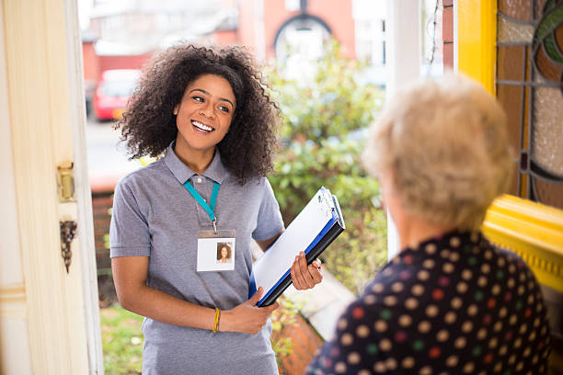
The city of Pasadena wants to know if there is sufficient support for a street design on N. Fair Oaks (from Washington to the border of Pasadena/Altadena). This would help to slow traffic, allow for more trees, cross walks, creating a sense of community… See the before and after image (if there is enough support).

Join us at 9am at the Harambee Center:
1609 Navarro, Pasadena, CA 91103
Or at 2pm at the Rio Meat Market:
2029 N. Fair Oaks, (meet at the inside café)
North Fair Oaks Image Rendering / Imagenes de antes y despues de North Fair Oaks
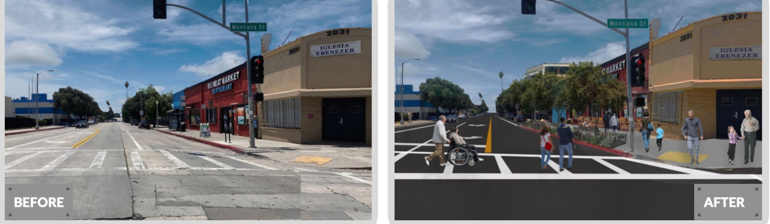
Please RSVP
https://www.signupgenius.com/go/10c0f44ada72fabfe3-survey
Or contact: Mario sethlume@hotmail.com or
Jill Shook Jill@makinghousinghappen.org 626-675-1316

